*To have your password reset, please contact the Business Applications Service Desk. They will reset your password, and you will receive two separate emails. One will be your VCSS user ID and the other will be your temporary password.*

Go to the **VCSS website** → [**https://vcss.ocfo.gsa.gov/Default.aspx**](https://vcss.ocfo.gsa.gov/Default.aspx)

Click on the “**Support Request**” button.

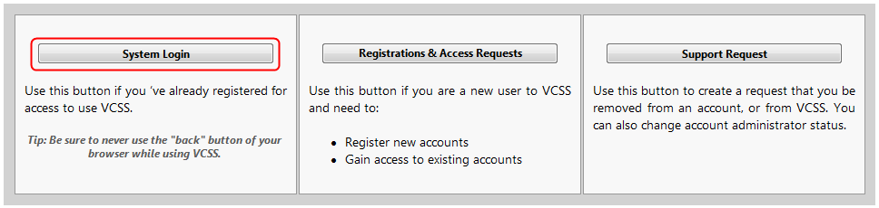

​

Click on the “**Statements**” tab, and choose the “**View and Print Statements**” sub-menu item.

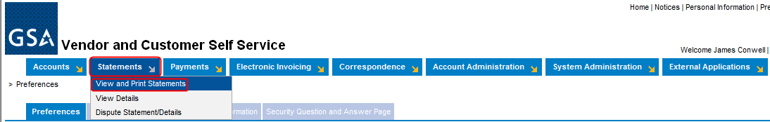

You can use any of the “**Search Criteria**” fields to perform the search. The most commonly used is “**Account Code**” (**BOAC**) or “**Agency Location Code**” (**ALC**) by which you want to view the statements/bills.

*Note: As you begin to search, the system will provide the list of accounts with that set of characters.

Then click “**Search**.”

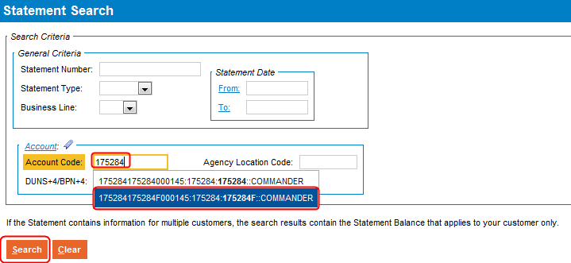

You will be presented with a list of all bills/statements for that Account Code or ALC. You may also have multiple pages of bills/statements; you can sort these in ascending or descending order by clicking on any of the column headings.

*Note: You can only view one bill/statement at a time. To download multiple statements, please repeat the following steps for each bill/statement you need to save/print.

To view, put a check in the box next to the bill/statement, and click the “**View PDF**” button.

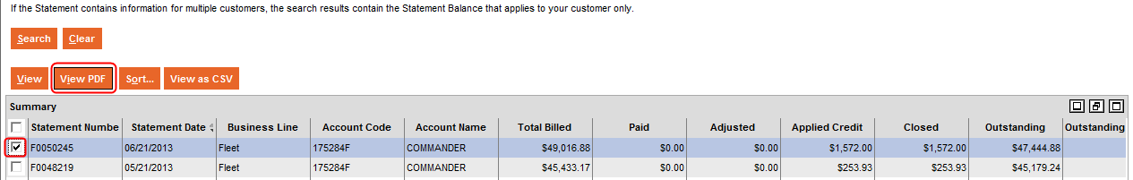

Your browser will refresh and, depending on your browser security settings, will indicate how to download the PDF file.

The most common steps will be for Internet Explorer to have a yellow pop-down window, stating that it is blocking the file from downloading to protect your security. Right-click on this message bar, and choose “**Download File …**”

You will then get an error message; click “**Retry**.”

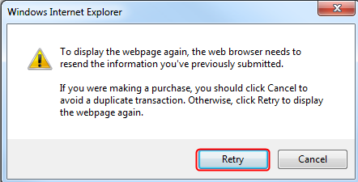

Choose “**Open**” or “**Save**."

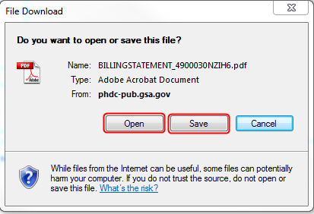

Once opened in Adobe, you can view, print and save the file.